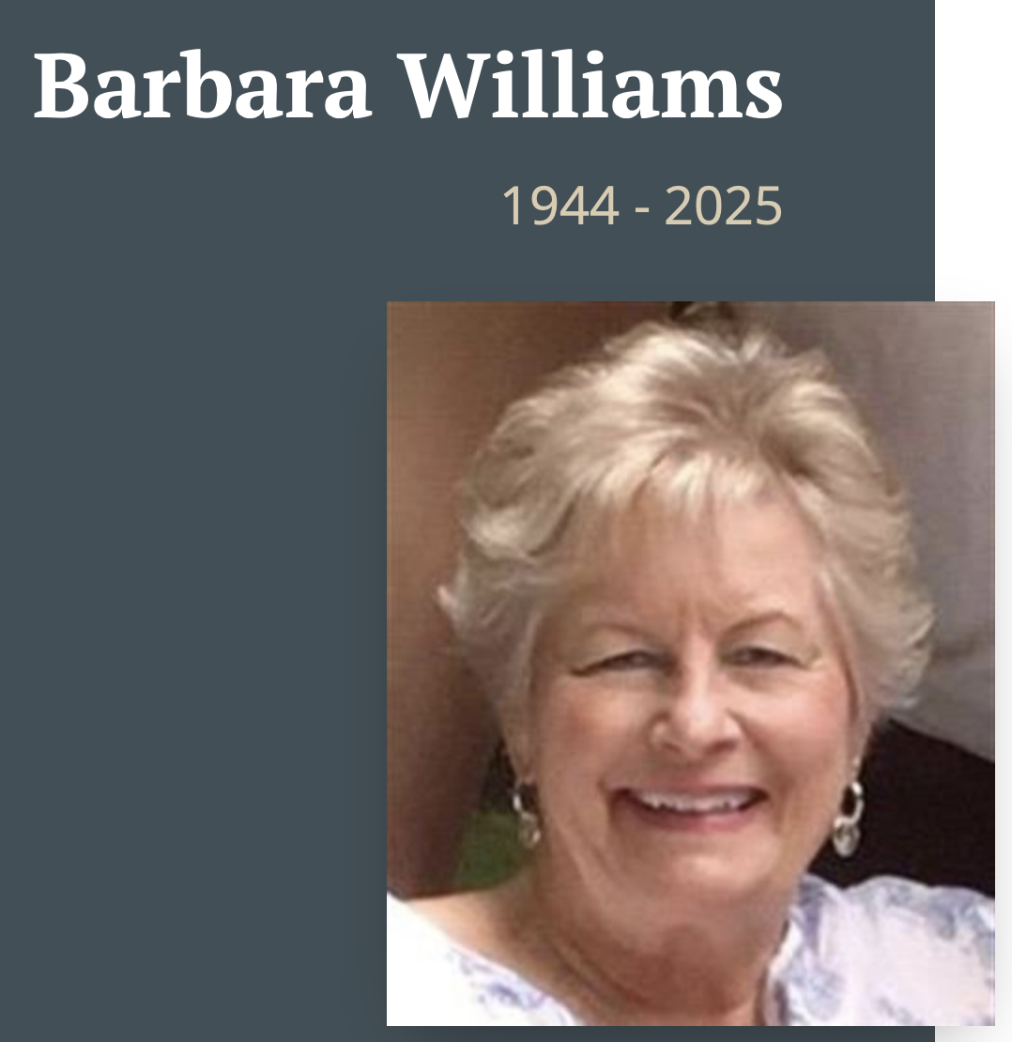
Barbara Ann Williams, 80, passed away at her residence in Brunswick, MD on October 17, 2025.
A mother, grandmother, friend, and active community member, she was known to be caring and supportive, kind, and loving. Growing up in Chewsville, MD and later moving to Hagerstown, MD, she attended North Hagerstown High School, Class of 1962.
She enrolled in, and graduated from, beauty school to become a beautician, and she worked in Hagerstown. After marriage in 1967, she assumed the role of wife, relocating to Baltimore, and went on to become a mother in 1971.
Her family moved to Brunswick in 1980 to become proprietors of the former Feete Funeral Home, as the John T. Williams Funeral Home. She later became the sole proprietor in 1982, and she continued to operate her business until her death.
She was active in the F.O.E. Women's Auxiliary, chapters of various Funeral Directors Associations, and the Brunswick Chamber of Commerce. She was a supportive donor to local schools, teams, and charitable organizations. She was a pillar and beloved member of the Brunswick community.
In her free time, she enjoyed gardening and exterior decorating. She prided herself in helping to beautify her business and the town with displays of seasonal cheer. She wanted everyone to feel welcome and to uplift those in need.
Barbara was the daughter of the late Orville and Edna Hoover. Sister to Terry Hoover of Smithsburg, MD, and the late Kelly Hoover. Barbara was the wife of the late John Williams and the mother of Scott Williams from Woodstock, NY, and Eric Williams from Lorton, VA. Grandmother to Aleida Ruth and Owen Brooks Williams.
Friends are invited to call on Saturday, November 1, 2025, and Sunday, November 2, 2025, from 2:00 pm to 4:00 pm and 7:00 pm to 9:00 pm each day at the John T. Williams Funeral Home, 100 Petersville Road, Brunswick, MD. A Funeral Service will be held at New Hope United Methodist Church, 7 South Maryland Avenue, Brunswick on Monday, November 3, 2025, at 11:00 AM. Reverend Katie O'Hern Hamilton will preside. Interment to follow in Brownsville Church of the Brethren Cemetery, 1911 Rohrersville Road, Knoxville, MD 21758, followed by food and fellowship in Brownsville Church of the Brethren Fellowship Hall. Condolences to the family may be made at www.harmanfunerals.com Barbara Williams

